|  |
| --- |
|  |
| Connected Components |
|  |

|  |
| --- |
| Chris Ruby  9-10-2018 |

# **Introduction**

This report is an investigation into the differences of N-4 Connectivity and N-8 Connectivity of a digital image. Figure one demonstrates the differences in pixels that will be looked at to evaluate a digital Image.

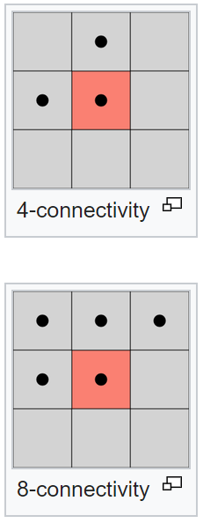

Figure :Connected Components

# N-4 Connectivity

The original pictures to be checked for N-4 connectivity were Skull.GIF and Isri_5g.GIF as seen below in Figure 2 and 3 respectfully.

# 

Figure : Skull.GIF

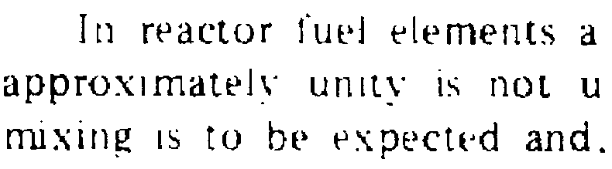

Figure : Isri_5g.GIF

For the Skull.GIF image the first step to accomplish N-4 Connectivity was to make the image into a binary image. This was accomplished by reading in the image into an array and walking through each element of the array, if the pixel value was greater than 128 then replace the value with a 1 and if the pixel value was less than 128 set to a 0.

The remaining steps hold true for both the Skull.GIF and isri_5g.GIF. The next step was to step through the array starting at the (0,0) (top left) position and check values from left to right, top to bottom. If the current pixel was a 0 then in a new array the value would be copied over, If the value was a 1 program would check the adjacent pixels (x,y-1),to the left and (x-1,y), above. If the pixel above and the pixel to the left were both zero then the program would put a K value starting at 1 and increment by 1 every time this case is met. If one of the adjacent pixels, above or left, were a one then the program will take that pixel position and transcribe that number into the current location. If the current location is a one and the adjacent pixels above and to the left are all ones then in the program will take one of the pixels top or to the left and search the array for that value and replace it with the other value. Upon going through every pixel of the picture and place a zero for off pixels and a value for non-zero pixels, the next step is to assign unique colors to each connected component. Skull color image can be seen in figure 4 and isri_5g colored image can be seen in figure 5. The colors were accomplished by using the unique function to tell me which unique numbers were used then a random unique R, B and G value was assigned to the unique number.

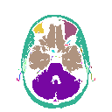

Figure :colored skull

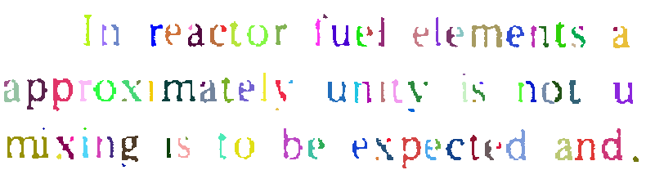

Figure :colored isri_5g

The final remaining step was to place boxes around each connected component. This was accomplished by reading in the array of connected values and using the function find_objects which takes in an int array and returns the non-zero coordinate values. With those values a box was able to be made. The connected boxes for the skull can seen in figure 6 and isri_5g can be seen in figure 7. The skull was found to have 47 connected components and Isri_5g was found to have 105 connected components.

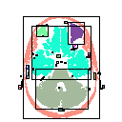

Figure : boxed connected components skull

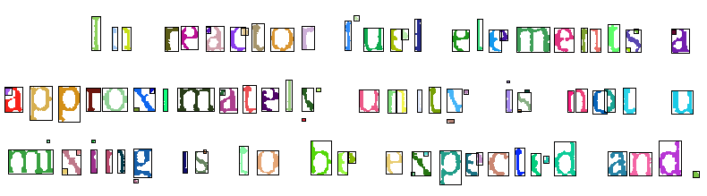

Figure : box components of Isri_5g

# N-8 Connectivity

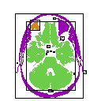

Figure : N8 Skull Connected Components

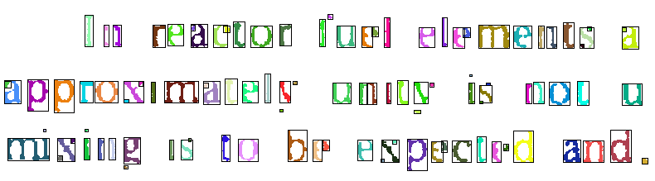

Figure : N8 isri_5g Connected Components

The total connected components of the skull using the N8 algorithm is 16. The total connected components of isri_5g is 104.

# Conclusion

Overall there was noticeably a bigger difference in connected components when comparing N-8 and N-4 in the skull.gif image. I believe each N-8 and N-4 have their place when looking at connected components in the real world. I believe for something in the medical field the more data the better so the N-8 connectivity would give the user more information to work with and for mostly everything else that does not need as much accuracy N-4 connectivity will be more than enough.